Filed by Rocket Lab Corporation

Pursuant to Rule 425 Under the Securities Act of 1933

and deemed filed pursuant to Rule 14a-12

under the Securities Exchange Act of 1934

Subject Company: Iridium Communications Inc.

Commission File No.: 001-33963

The following communications were first made available on Rocket Lab Corporation’s (“Rocket Lab”) X, Facebook, LinkedIn, Instagram and BlueSky on June 29, 2026.

X
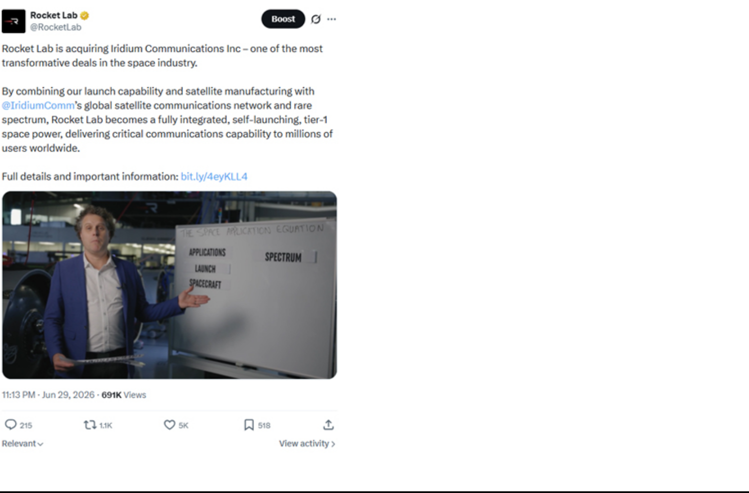

Facebook
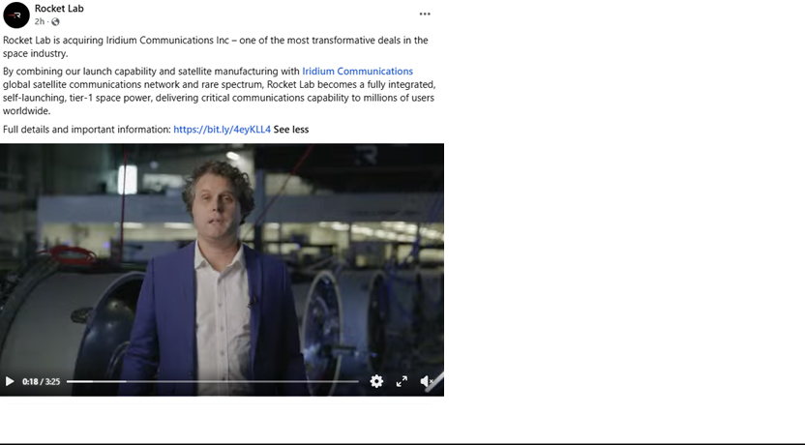

LinkedIn
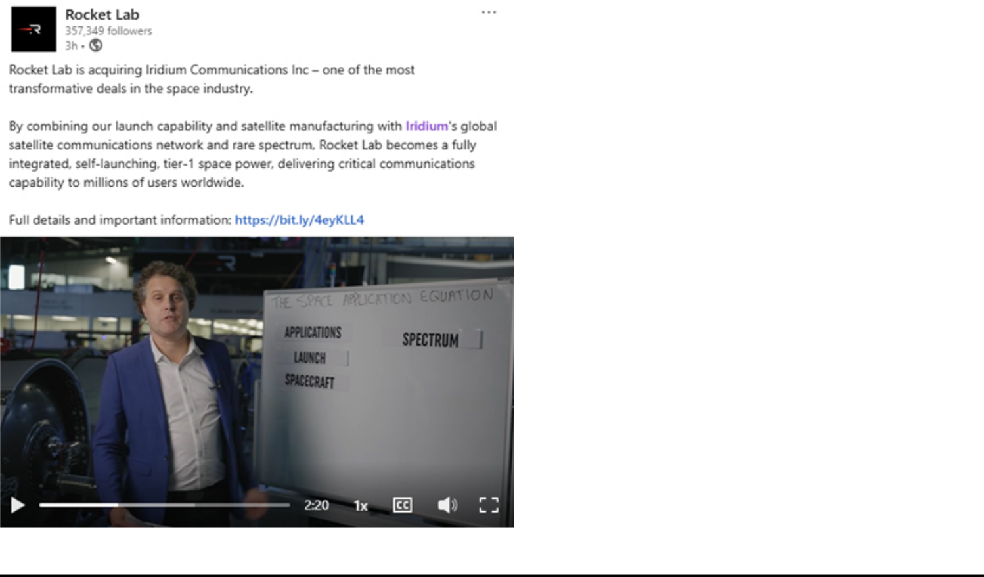

Instagram


BlueSky
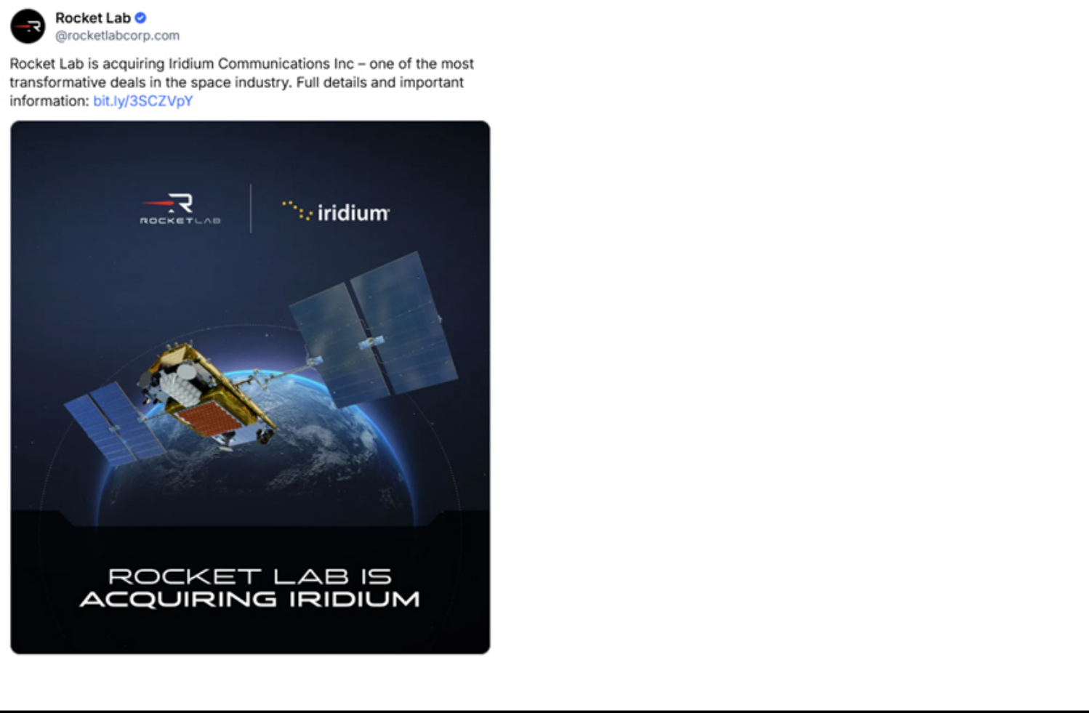

The following transcript was made available for an interview that was published on Rocket Lab’s YouTube account on June 29, 2026:

Last time I was wearing this blue jacket I was announcing Neutron. So I guess that means there's something important to announce today.

But man, this thing shrunk.

Okay we're going to go back to school for a little bit. I want to introduce you to the space application equation.

So you've heard me talk a lot in the past about applications. It's where all the value in space truly lies. But in order to exploit that value to the fullest you need a few other things.

The first thing is unfettered access to space. So you need your own launch.

And then of course you need your own ability to build spacecraft at scale. We've got that too.

But there's some other really big barriers to building large successful constellations in orbit. And the first one? Spectrum. Spectrum is a finite, almost impossible to get. And of course not all spectrum is created the same.

The next thing is it takes a long time to build and launch your infrastructure. A long time to design and build your satellites, launch them, and even a longer time to get your first one dollar of revenue.

And then finally, it's a long time to a sustained cash flow model. A long time to build your business model. A long time to build your customer base. And it takes just that long extended time until you've got proper reoccurring cash flow.

So those of you who know me will know that I'm way too impatient for that. So we've found a bit of a shortcut.

Rocket Lab is acquiring Iridium Communications.

We believe this will be one of the most transformative deals in the space industry. It's the ultimate combination for growth. And if you think back to our little whiteboard session a moment ago, this is a deal where one plus one equals three, not just two.

One being Rocket Lab, we have unfettered access to space and the ability to build spacecraft at scale. We also do missions for people that matter.

And then you think of Iridium, they have an already operational constellation. Spectrum, not just any spectrum, extremely valuable spectrum, millions of customers and they're a profitable business.

So where the three comes in is the result of these two things is a fully integrated, self-launching space superpower. One that will unlock more growth from Iridium's existing network and build new constellations to unlock new services and market opportunities.

This is an ignition point for Rocket Lab.

This is officially our entrance into the space applications market. A thing we've been talking about for a long time now. But to be clear, this is not the finish line.

Now we won't just continue Iridium's network as is. We're going to build upon it to unlock new markets and pioneer new space projects.

Rocket Lab's future in space applications has just been unlocked and accelerated.

And with that, I'm off to buy a new jacket. This thing is too small.

Additional Information and Where to Find It

This communication is being made in respect of a proposed transaction involving Rocket Lab Corporation (“Rocket Lab”) and Iridium Communications Inc. (“Iridium”). In connection with the proposed transaction, Rocket Lab will file with the Securities and Exchange Commission (the “SEC”) a Registration Statement on Form S-4 that includes the proxy statement of Iridium that will also constitute a prospectus of Rocket Lab. When the proxy statement/prospectus is finalized, it will be sent to the stockholders of Iridium seeking their approval of certain transaction-related proposals. This communication is not a substitute for the proxy statement/prospectus or any other documents which Rocket Lab or Iridium may file with the SEC in connection with the proposed transaction.

Rocket Lab may not sell the common stock referenced in the proxy statement/prospectus until the Registration Statement on Form S-4 filed with the SEC becomes effective. The preliminary proxy statement/prospectus and this communication are not offers to sell any securities, are not soliciting an offer to buy any securities in any state where the offer and sale is not permitted and are not a solicitation of any vote or approval.

ROCKET LAB AND IRIDIUM URGE INVESTORS AND SECURITY HOLDERS TO READ THE REGISTRATION STATEMENT ON FORM S-4, THE RELATED PROXY STATEMENT/PROSPECTUS INCLUDED THEREIN AND OTHER DOCUMENTS FILED WITH THE SEC CAREFULLY AND IN THEIR ENTIRETY WHEN THEY BECOME AVAILABLE BECAUSE THEY WILL CONTAIN IMPORTANT INFORMATION ABOUT THE PROPOSED TRANSACTION.

Investors and security holders will be able to obtain these materials (when they are available and filed) free of charge at the SEC’s website, www.sec.gov. Copies of documents filed with the SEC by Rocket Lab (when they become available) may be obtained free of charge on Rocket Lab’s website at https://investors.rocketlabcorp.com/financial-information/sec-filings or by contacting Rocket Lab’s Investor Relations Department at investors@rocketlabusa.com. Copies of documents filed with the SEC by Iridium (when they become available) may be obtained free of charge on Iridium’s website at https://investor.iridium.com/sec-filings by contacting Iridium’s Investor Relations Department at investor.relations@iridium.com.

Participants in the Solicitation

Robert H. Niehaus, Louis M. Alterman, Thomas C. Canfield, Matthew J. Desch, Thomas J. Fitzpatrick, L. Anthony Frazier, Suzanne E. McBride, Eric T. Olson, Kay N. Sears, Monique S. Shivanandan and Jacqueline E. Yeaney, all of whom are members of Iridium’s board of directors, and Vincent J. O’Neill, Iridium’s chief financial officer, may be considered participants in Iridium’s solicitation. Information regarding such participants, including their direct or indirect interests, by security holdings or otherwise, will be included in the proxy statement/prospectus and other relevant documents to be filed with the SEC in connection with the transaction. Additional information about such participants is available under the captions “Proposal 1 – Election of Directors,” “Director Compensation” and “Security Ownership of Certain Beneficial Owners and Management” in Iridium’s definitive proxy statement in connection with its 2026 Annual Meeting of Stockholders (the “2026 Proxy Statement”), which was filed with the SEC on April 2, 2026 (which is available at https://www.sec.gov/ix?doc=/Archives/edgar/data/0001418819/000141881926000022/irdm-20260402.htm), as well as on Iridium’s Annual Report on Form 10-K for the fiscal year ended December 31, 2025, which was filed with the SEC on February 12, 2026 (the “2025 10-K”) and certain of Iridium’s Quarterly Reports on Form 10-Q and Current Reports on Form 8-K. To the extent that holdings of Iridium’s securities have changed since the amounts printed in the 2026 Proxy Statement, such changes have been or will be reflected on Statements of Change in Ownership on Form 4 filed with the SEC (which are available at https://www.sec.gov/cgi-bin/own-disp?action=getissuer&CIK=0001418819). Information regarding Iridium’s transactions with related persons is set forth in the 2026 Proxy Statement under the caption “Transactions with Related Parties,” as well as on the 2025 10-K and certain of Iridium’s Quarterly Reports on Form 10-Q and Current Reports on Form 8-K. Certain illustrative information regarding the payments that may be owed, and the circumstances in which they may be owed, by Iridium to its named executive officers in a change of control of Iridium is set forth in the 2026 Proxy Statement under the caption “Severance and Change in Control-Related Benefits,” as well as on the 2025 10-K and certain of Iridium’s Quarterly Reports on Form 10-Q and Current Reports on Form 8-K. Rocket Lab may also be deemed to be a participant in Iridium’s solicitation; information regarding Rocket Lab will be included in the proxy statement/prospectus and other relevant documents to be filed with the SEC in connection with the transaction. Copies of these documents may be obtained, free of charge, from the SEC or Iridium as described in the preceding paragraph.

Cautionary Note Regarding Forward-Looking Statements

This communication contains “forward-looking statements” within the meaning of the federal securities laws. These forward-looking statements are based on Rocket Lab’s and Iridium’s current expectations, estimates and projections about the expected date of closing of the proposed transaction and the potential benefits thereof, its business and industry, management’s beliefs and certain assumptions made by Rocket Lab and Iridium, all of which are subject to change. In this context, forward-looking statements often address expected future events, including future business and financial performance and financial condition. All forward-looking statements by their nature address matters that involve risks and uncertainties, many of which are beyond our control, and are not guarantees of future results, such as statements about the consummation of the proposed transaction and the anticipated benefits thereof. These and other forward-looking statements are not guarantees of future results and are subject to risks, uncertainties and assumptions that could cause actual results to differ materially from those expressed or implied in any forward-looking statements. Accordingly, there are or will be important factors that could cause actual results to differ materially from those indicated in such statements and, therefore, you should not place undue reliance on any such statements and caution must be exercised in relying on forward-looking statements. Important risk factors that may cause such a difference include, but are not limited to: (i) the completion of the proposed transaction on anticipated terms and timing, or at all, including obtaining stockholder and regulatory approvals and satisfying other conditions to the completion of the transaction; (ii) the occurrence of any event, change or other circumstances that could give rise to the termination of the merger agreement, including the receipt by Iridium of an unsolicited proposal from a third party; (iii) failure to realize the anticipated benefits of the proposed transaction on a timely basis or at all, including anticipated tax treatment, unforeseen liabilities, future capital expenditures, revenues, expenses, earnings, the integration of the businesses of Rocket Lab and Iridium, synergies, economic performance, indebtedness, financial condition, losses, future prospects, business and management strategies for the management, expansion and growth of Rocket Lab’s and Iridium’s businesses; (iv) Rocket Lab’s and Iridium’s ability to implement their business strategies; (v) potential litigation relating to the proposed transaction that could be instituted against Rocket Lab, Iridium or their respective directors, managers, or officers, including the effects of any outcomes related thereto; (vi) the risk that disruptions from the proposed transaction will harm Rocket Lab’s or Iridium’s businesses, including current plans and operations, or will otherwise divert management time from ongoing business operations on transaction-related issues; (vii) the ability of Rocket Lab or Iridium to retain and hire key personnel; (viii) potential adverse reactions or changes to business relationships resulting from the announcement or completion of the proposed transaction; (ix) fluctuations in, and uncertainty as to the long-term value of, Rocket Lab or Iridium common stock (including as relating to the risk that any announcements related to the proposed transaction could have adverse effects on the market price of such stock); (x) legislative, regulatory and economic developments affecting Rocket Lab’s and Iridium’s businesses, including actions by government agencies and third parties; (xi) general economic and market developments and conditions, potential changes to international trade relations, geopolitical conflicts and effects from global pandemics, epidemics, or other public health crises; (xii) the evolving legal, regulatory and tax regimes under which Rocket Lab and Iridium operate; (xiii) restrictions during the pendency of the proposed transaction that may impact Rocket Lab’s or Iridium’s ability to pursue certain business opportunities or strategic transactions; (xiv) unexpected costs, charges or expenses resulting from the proposed transaction; (xv) risks that any debt or other financing anticipated in connection with the proposed transaction is not obtained or that such financing cannot be obtained on the anticipated timing or terms or unexpected costs or expenses in connection therewith; and (xvi) the other risks and uncertainties, as described in the periodic reports that Rocket Lab and Iridium file with the SEC. These risks, as well as other risks associated with the proposed transaction, are more fully discussed in the proxy statement/prospectus to be filed with the SEC in connection with the proposed transaction. Neither Rocket Lab nor Iridium assumes any obligation to publicly provide revisions or updates to any forward-looking statements, whether as a result of new information, future developments or otherwise, should circumstances change, except as otherwise required by securities and other applicable laws. Forward-looking statements included in this communication are made as of the date of this communication.

